**ТЕХНОЛОГИЯ WINDOWS PRESENTATION FOUNDATION**

Задание 1.

Листинг программы:

<Window x:Class="WpfApp1.MainWindow"

xmlns="http://schemas.microsoft.com/winfx/2006/xaml/presentation"

xmlns:x="http://schemas.microsoft.com/winfx/2006/xaml"

xmlns:d="http://schemas.microsoft.com/expression/blend/2008"

xmlns:mc="http://schemas.openxmlformats.org/markup-compatibility/2006"

xmlns:local="clr-namespace:WpfApp1"

mc:Ignorable="d"

Title="MainWindow" Height="450" Width="800">

<Grid x:Name="LayoutRoot" Background="White">

<Grid.RowDefinitions>

<RowDefinition/>

<RowDefinition/>

<RowDefinition/>

</Grid.RowDefinitions>

<TextBlock x:Name="textBlockHello" Grid.Row="0"/>

<TextBox x:Name="textBoxEnterName" Grid.Row="1"/>

<Button x:Name="buttonRun" Content="Сказать Имя" Grid.Row="2" Click="buttonRun_Click"/>

</Grid>

</Window>

namespace WpfApp1

{

/// <summary>

/// Interaction logic for MainWindow.xaml

/// </summary>

public partial class MainWindow : Window

{

public MainWindow()

{

InitializeComponent();

}

private void buttonRun_Click(object sender, RoutedEventArgs e)

{

string hello = "Hello";

string input = string.Empty;

if (string.IsNullOrEmpty(textBoxEnterName.Text)

|| string.IsNullOrWhiteSpace(textBoxEnterName.Text))

{

input = "World!";

}

else

{

input = textBoxEnterName.Text;

textBlockHello.Text = $"{hello} {input}";

}

<Window x:Class="WpfApp1.AboutApp"

xmlns="http://schemas.microsoft.com/winfx/2006/xaml/presentation"

xmlns:x="http://schemas.microsoft.com/winfx/2006/xaml"

xmlns:d="http://schemas.microsoft.com/expression/blend/2008"

xmlns:mc="http://schemas.openxmlformats.org/markup-compatibility/2006"

xmlns:local="clr-namespace:WpfApp1"

mc:Ignorable="d"

Title="AboutApp" Height="450" Width="800">

<Grid x:Name= "LayoutAbout">

<Grid.RowDefinitions>

<RowDefinition Height="2"/>

<RowDefinition Height="*"/>

</Grid.RowDefinitions>

<TextBlock x:Name="textBlockInfo" Grid.Row="0" Grid.ColumnSpan="2"/>

<TextBlock x:Name="TextBoxEnterName" Grid.Row="0" Grid.ColumnSpan="2"/>

<Button x:Name="buttonRun" Content="Cказать имя" Width="200" Height="60" Grid.Row="1" Click="ButtonRun_Click" Margin="87,336,513,36"/>

<Button x:Name="buttonAbout" Content="Справка" Grid.Row="1" Width="200" Height="60" Margin="534,336,66,36" Click="buttonAbout_Click" />

</Grid>

</Window>

|  |  |
| --- | --- |
| Входные данные | Выходные данные |
| Имяяя | Hello Имяяя |

Анализ результатов:

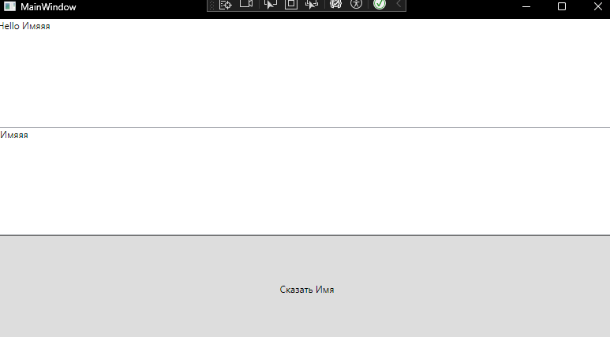

Рисунок 1 – Результат работы программы: